**Members:**

Dilshawn Sahi

Sultan Adil

Tyler Gross

Kashyap Kandikonda

**Progress**:

We have finished working on our battleship project. We developed our pseudo code into executable code and have connected all our group members code together. Our framework is pygame, and we have developed a playing board.

**Github**:

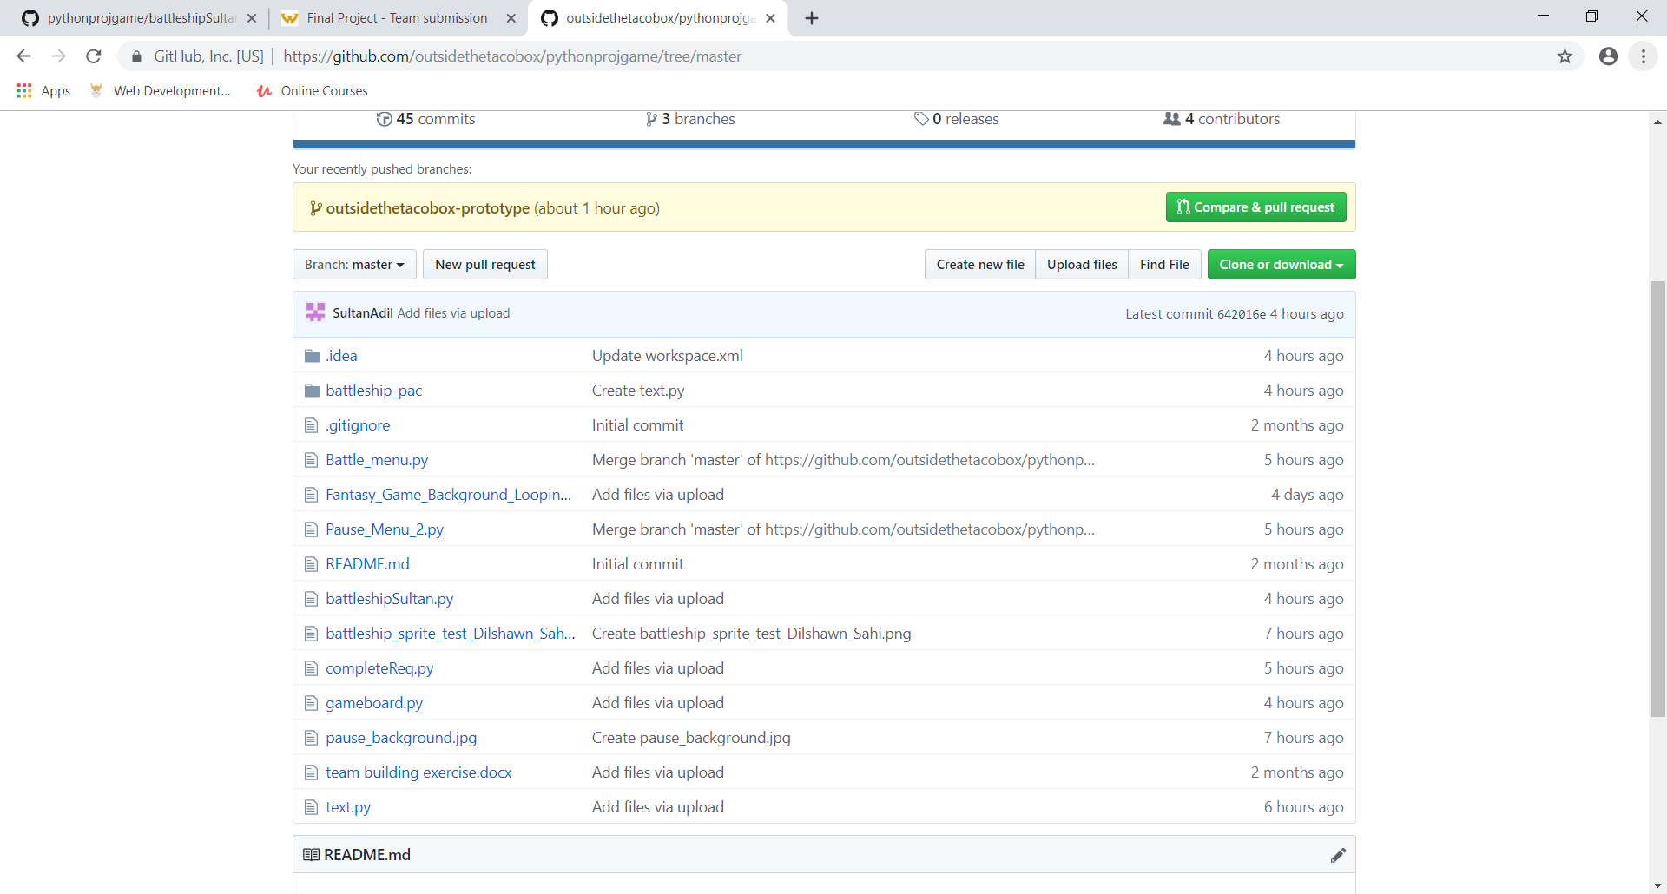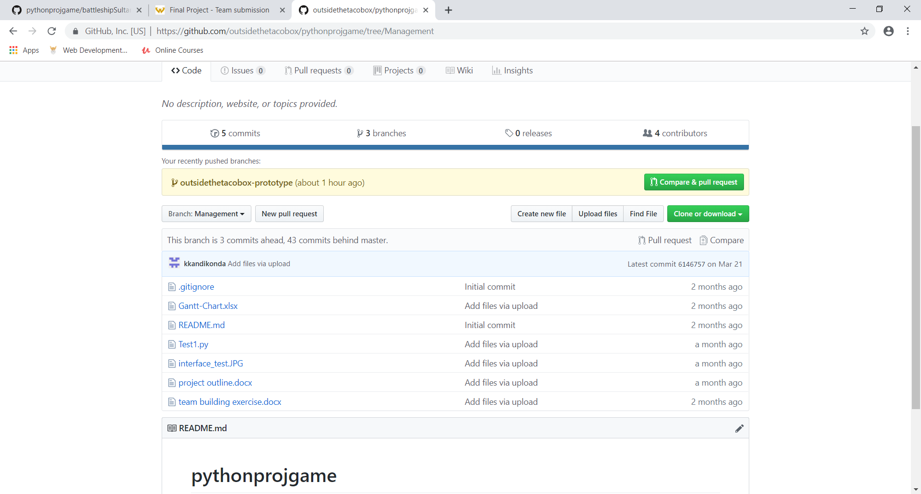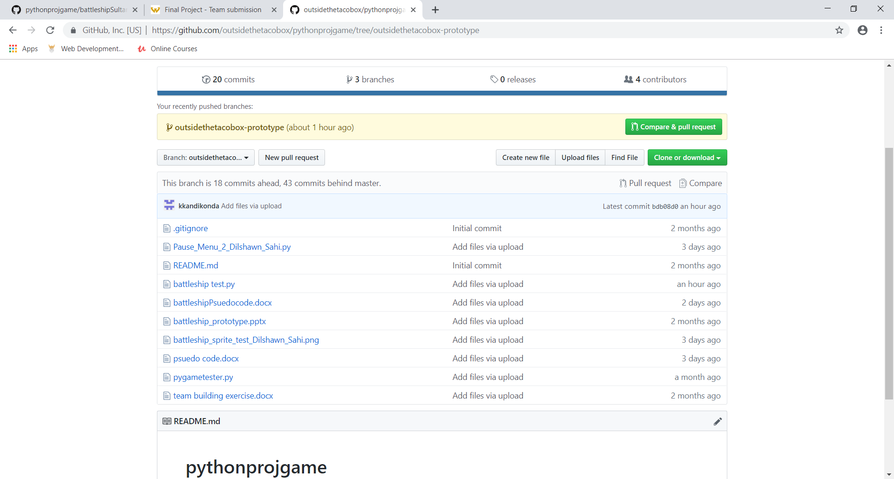

In our github we have 3 folders. The master branch is the main branch where all we put all the files that we think will need to be in the final project submission. We also have the management branch which is where all planning documents are located. Our outsidethetaco-prototype branch is where we put all files that we individually came up with and need to be combined with other pieces of code from other users. We used this as a staging area to connect all our code.

**Team** **Dynamic**:

We have a good team dynamic and are productive in class. We discuss our ideas with each other. We have a team of 4, so we can evenly divide the project into different parts so that we can all work on different parts and still help each other. The scope of our project has been the same since the start. We defined our project based on the rubric so that we were able to follow the guidelines and still learn. We have been following the gantt chart, and we are able to complete the tasks based on the original timeline. We all collaborate equally, so there is no leader, but we are all responsible for our own work. The weekly team reviews were helpful so that we can check the progress everyone has made and make plans accordingly.